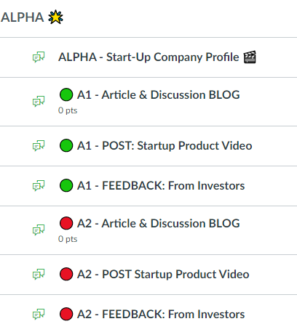
Your team name. Follow the schedule in the syllabus to see who is up during a week.
This is so the other groups can get to know about you and your StartUp. Use the PPT template in Canvas under StartUp Company Profile to create this.
This is where the class will respond to your KarpTank Demo. You can answer replies from this area.
This is where you post your article. Individual student replies will also be posted here…

This is the same as above, but for your second KarpTank discussion. Stay organized please.

This is only for your team KarpTank video link if we are online.

Download this Doc. File in Canvas for image Clarity: This is what the individual article reply will look like. The article will be posted by each team and then your reply is due at a specific time. Late submission will not be graded.
